Information on War Memorial Maintenance

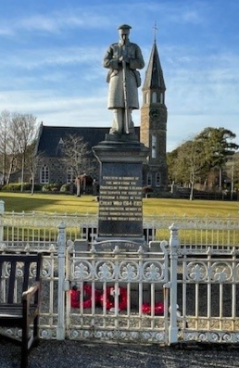
War Memorials understandably play an important role within communities and the Council receive comments around their condition, particularly in the lead up to Remembrance Sunday commemorations. The most common question or request is for a clean of a Memorial. We thought it would be useful to share information on the Council’s responsibilities and provide some guidance around caring for Memorials with this being the 80th Anniversary of VE and VJ days and the potential increase in Remembrance Events.

Aberdeenshire Council is custodian of War Memorials within the Council boundary and under Legislation may take on maintenance responsibility but are not obliged to do so. The Council’s Historic Asset Management Project (HAMP) is responsible for surveying all historic assets owned or in the guardianship of the Council, to ensure all visitors and our own operatives can access a site safely. There are approximately 500 assets on the list to monitor and include historic churchyards, buildings, monuments as well as War Memorials.

Tasks such as cleaning of War Memorials or maintenance such as re-lettering is not within the remit of HAMP. War Memorials in Aberdeenshire sit on the HAMP list for the purposes of monitoring their structural condition through surveys, usually undertaken every 5 years – or sooner if a Health & Safety issue arises. HAMP’s interest in War Memorials is to ensure the structure is stable to allow people to visit a monument safely.

The Council are also asked by community groups or individuals within a community if they can organise a clean themselves. We are not against that in principle but we would always caution against cleaning to create a pristine appearance; every time a memorial is cleaned it has a negative impact on the longevity of the memorial and so we would advise to carefully consider if this is the right point in time to clean the monument. The main focus of cleaning should be to ensure that the names can be clearly read and to prevent further deterioration. That said it is also best to clean when the weather is warm and the likelihood of frost is low, so the summer months are more appropriate.

Below are some links to useful guidance on cleaning from the War Memorials Trust. This includes a section on striking a balance between cleaning and when best to leave the monument. Within the War Memorials Trust document, there is an offer of assistance to assess whether cleaning would be appropriate and there is a section on potential funding. Also linked below is the Short Guide ‘The Repair and Maintenance of War Memorials’ prepared by Historic Environment Scotland.

Conservation: Cleaning Guidance Note from War Memorials Trust:
Cleaning WMT

The Repair and Maintenance of War Memorials, Historic Environment Scotland:
Cleaning HES

War Memorials Trust FAQ Page: FAQs - War Memorials Online

If an individual or group instruct a professional clean of the monument, they must do so understanding that Aberdeenshire Council cannot help fund the work.

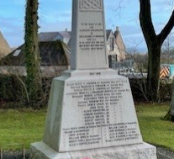
In terms of Council process, if a clean is undertaken, the organiser should take photos of the ‘before’ and ‘after’ of all four ‘sides’ of the Memorial and submit these with the methodology of how the work was undertaken to the following email address, with confirmation of when the work was completed: hamp@aberdeenshire.gov.uk
This helps us assess the rate of deterioration if we have a range of dated photos.

The War Memorials Trust can be contacted by email: conservation@warmemorials.org or by telephoning 020 7233 7356.

If a War Memorial is structurally unstable and poses a risk to the public, this can be reported by emailing: hamp@aberdeenshire.gov.uk

